**Screen shots of Tested Scenarios:**

**Test Scenarios:**

1. **Enter New Customer Details correctly, which gets added to Current Queue**

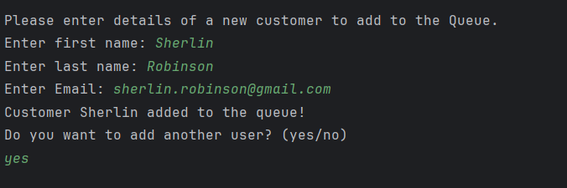

1. **Setting the Current Queue size to 5, and if queue size exceeds,**

**- Customer get added to Wait List.**

**- First customer from Current queue reached limit and gets moved to Processed Queue**

**- Processed queue Customer gets removed and inserted in customers table in MS SQL DB**

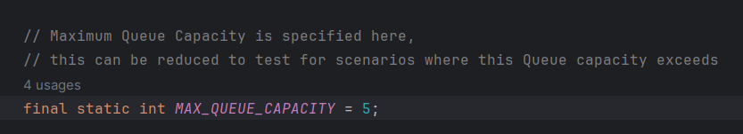

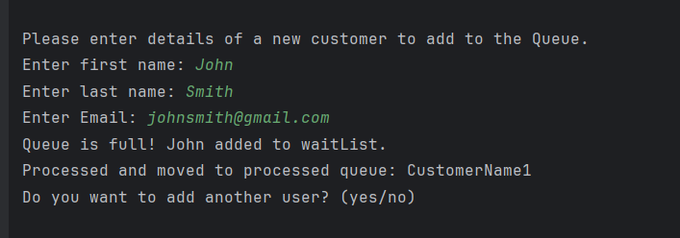

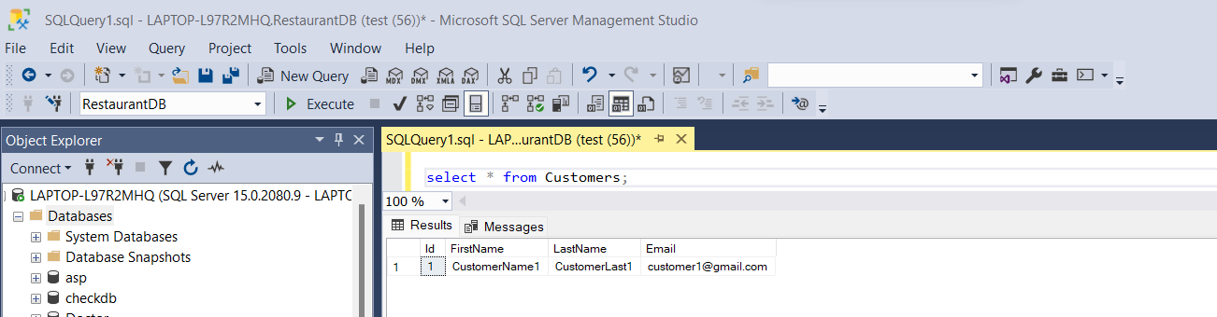

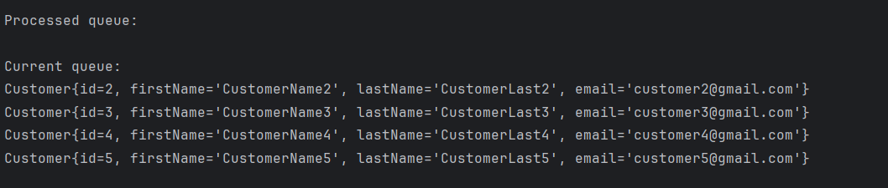

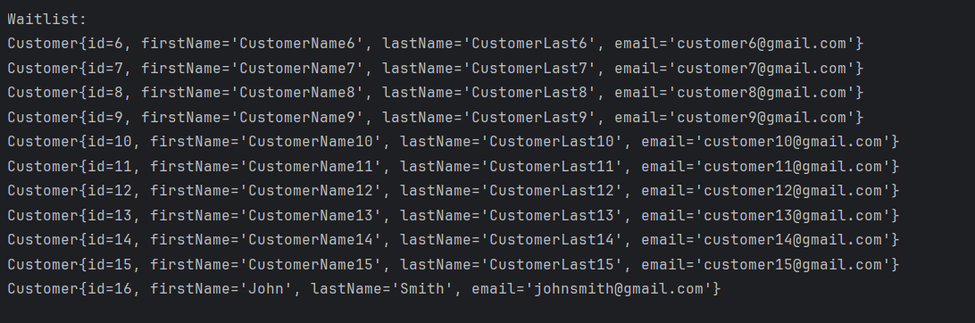

1. **Validations performed when adding New Customer Details:**

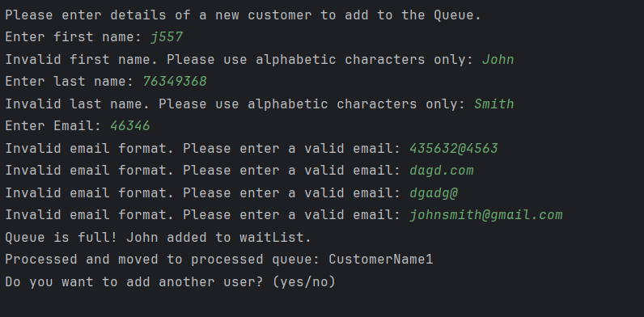

1. **Validations performed to avoid duplicates when adding a New Customer with already existing email ID:**

